GIT Hub Account Creation Steps—

1. Navigate to [github.com](https://github.com/) in your web browser.

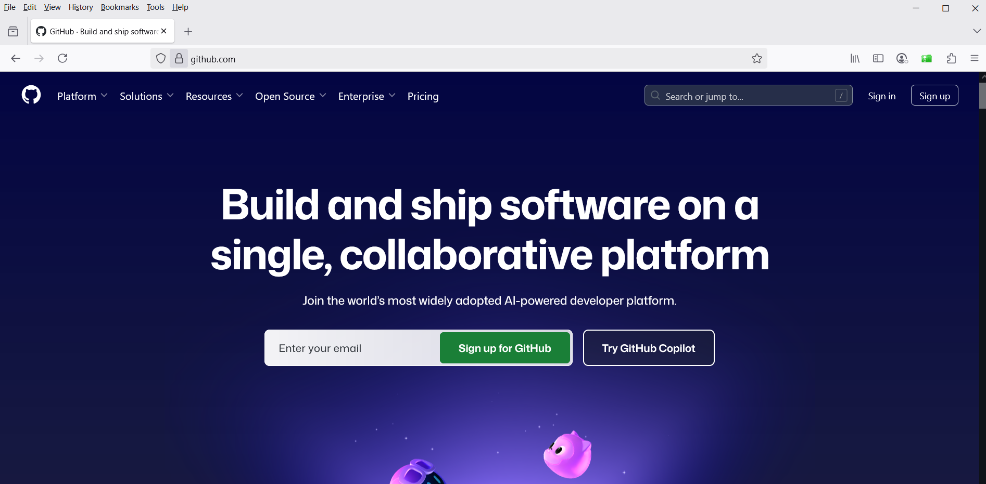

2. **Sign Up:** You will see a form to create your account.

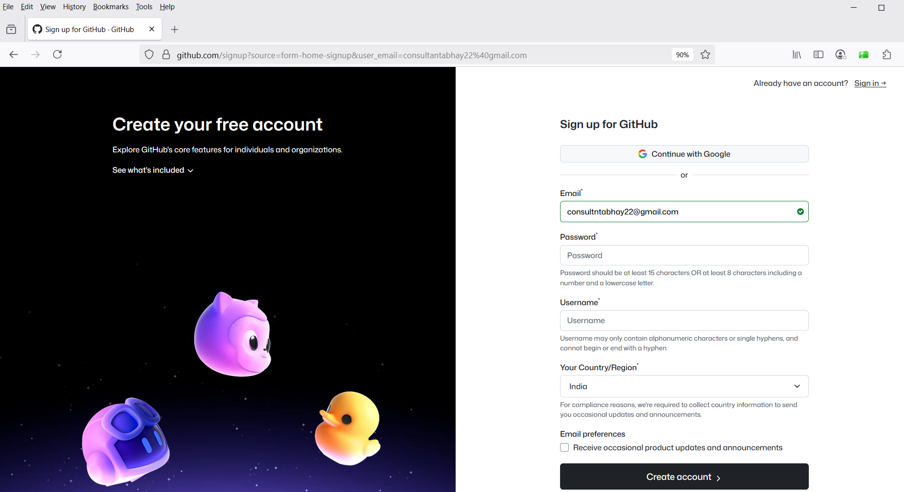

1. **Verify Your Account:** You will be asked to solve a simple puzzle to verify you are not a robot.

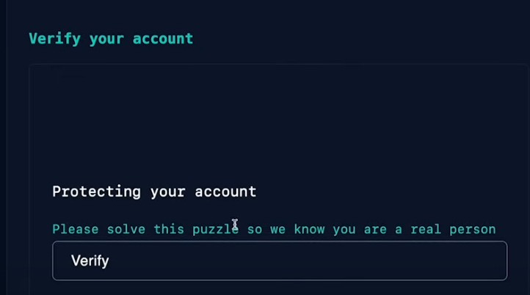

1. **Optional: Tailored Experience:** GitHub may ask if you want to receive product updates and recommendations. You can choose yes or no.
2. **Verify Your Email:** GitHub will send a verification code to the email address you provided. Enter this code on the website to complete the setup.

 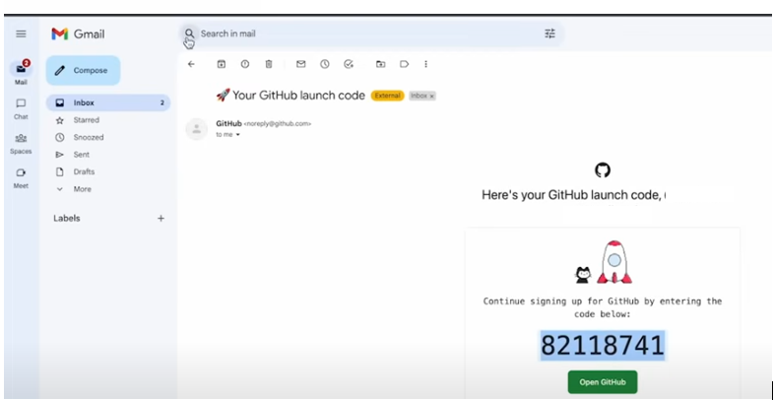

1. **Welcome!** Your account is now active. You can start exploring.

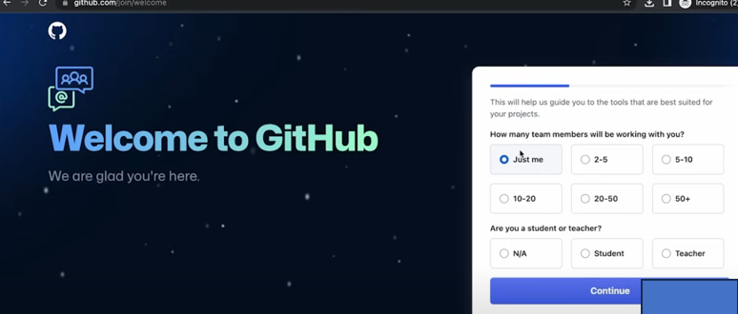



1. Click Continue and final click on Free.
2. Students can apply for additional benefits through college emails.
3. After signup, users gain access to a dashboard showing profile activity and repositories.
4. Finally, dashboard page open

